TITLE
WorkFlowX

SYSTEM DESIGN

SUBMITTED BY :-
Adwaith K- 23827
Jeshal Dsouza – 23835
Ashija Kotian – 23846

Employment Management System (EMS)

System Analysis
The Employment Management System is designed to manage all employee-related activities in an organization. It automates tasks such as maintaining employee records, tracking attendance, managing leaves, generating payroll, and producing reports. Employees, managers, and administrators can access the system according to their roles. The system ensures accurate and secure data, reduces manual work, and helps the organization operate efficiently. By centralizing employee information, the system improves reliability, reduces errors, and makes reporting and payroll processing easier.

System Design
The system is a web-based application organized into main modules. The key modules are Employee Management, Attendance Management, Leave Management, Payroll Management, and Report Generation. Each module interacts with the centralized database to store and retrieve information. Employees can view and update their details, apply for leave, and check attendance. Managers can approve leave requests and access reports. Administrators manage employee records, payroll, and generate reports. The design ensures smooth flow of data between modules, external entities, and the database, providing a clear structure for implementation.

Context Flow Diagram
The context flow diagram represents the Employment Management System as a single process interacting with external entities. The main external entities are Employee, Manager, and Admin. Employees provide login details, submit requests, and update personal information, and the system responds with status updates and reports. Managers provide approvals and queries and receive reports and notifications. Admins manage system data and receive confirmations and system-generated reports. This diagram defines the system Boundary and shows interactions between the system and external entities.
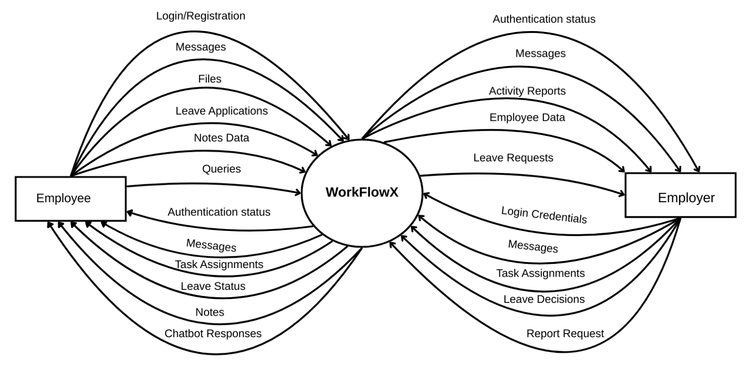

Description:
The context flow diagram clearly shows the EMS as one process and demonstrates how the external entities interact with it. It provides a high-level view of the system boundary and data flow.

Data Flow Diagrams
Data flow diagrams illustrate how data moves through the system, how processes interact, and how data stores are used.
Notation Table:

DIAGRAM | DESCRIPTION
 | Represents Source or destination of data
0 | Represents a process that transforms Incoming data into Outgoing flows
 | Represents data flow
 | Represents data stores

0

Level 1 DFD
Level 1 decomposes the WorkFlowX System into its major processes. The main modules shown in this level are Employee Management, Attendance Management, Leave Management, Payroll Management, and Report Generation. This diagram also shows interactions with external entities and data stores.
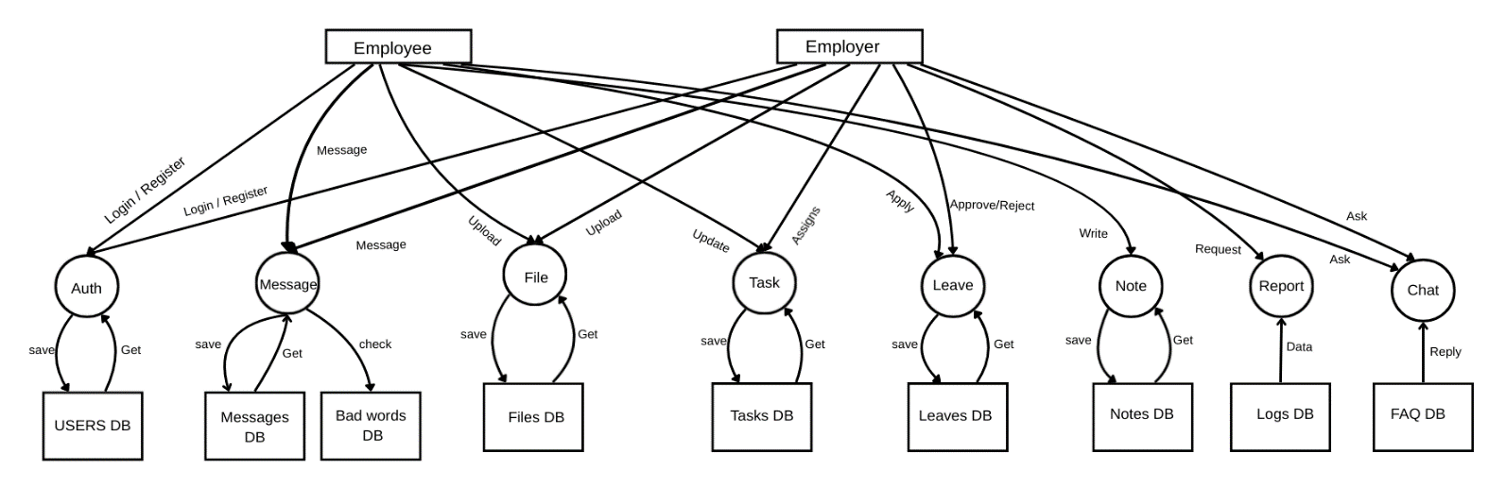

Description:
The Level 1 DFD provides an overview of the major processes of EMS and how data flows between these processes, external entities, and data stores.

Level 2 DFD

2.1 Messaging System
This Level 2 diagram provides a detailed breakdown of the Messaging System, showing the sub-processes involved in sending and receiving messages with the bad-word filtering mechanism.

Key Feature:
The bad-word filtering mechanism ensures professional communication by automatically censoring inappropriate content while preserving the original message for audit purposes.

Data Flow:
When a user sends a message, it is validated, checked for bad words, censored if necessary, stored in the database, and the receiver is notified. If validation fails, an error is sent back to the sender.

